Ideation Phase

Empathize & Discover

Date | 04 August 2026
Project Name | Automated Network Request Management in ServiceNow
Maximum Marks | 4 Marks

Empathy Map Canvas:
An empathy map is a simple and easy-to-understand visual tool used to capture user behaviors, needs, and expectations.
It helps project teams better understand users and design solutions that address real challenges.
Creating an effective solution requires understanding the actual problem faced by users and considering their goals, frustrations, and expectations.

EMPATHY MAP
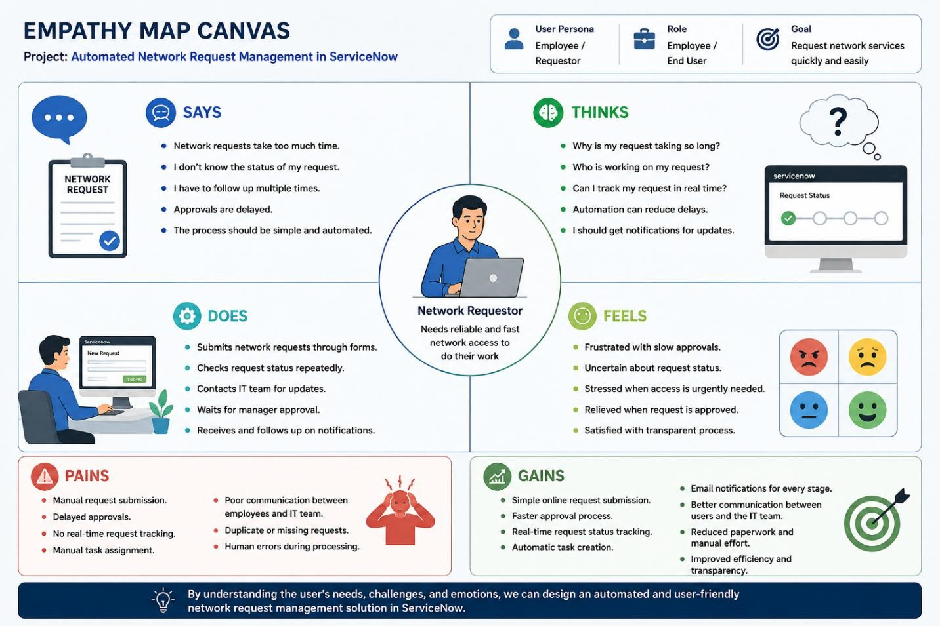

Uses of an Empathy Map:
- Helps understand the user's needs, expectations, and problems.
- Identifies challenges faced during the network request process.
- Provides insight into user thoughts, actions, and emotions.
- Helps analyze pain points such as delayed approvals and lack of tracking.
- Supports designing a user-friendly and automated solution.
- Improves communication between users and the IT/Network team.
- Helps create efficient workflows in ServiceNow.
- Enables development of solutions that improve user experience and productivity.

